

McKinney PS and NU,
Dundrod

School Uniform Policy
2025 - 2028

Introduction

It is our policy that all children should wear school uniform when attending McKinney Primary School and Nursery Unit, Dundrod, or when participating in a school-organised event outside normal school hours.
Our school uniform is important to us. It helps us identify ourselves as a school family.
We believe it promotes a strong, cohesive identity which supports high standards and expectations in all areas of school life.
Our school uniform promotes harmony between different groups represented in the school and it enhances security, assisting the school to identify individual pupils in order to maintain good order and spot intruders more easily.
We believe that by wearing a school uniform, we promote effective discipline which contributes to more effective learning and teaching.

This Policy adheres to the guidelines provided by the Department of Education Northern Ireland
(Circular 2011/04) (Re-issued 5 June 2018).

Rationale

Our policy is based on the notion that a school uniform:

• promotes a sense of pride in the school;

• engenders a feeling of community and belonging;

• is practical and smart;

• identifies the children with the school;

• is not distracting in class (as current trends might be);

• makes children feel equal to their peers in terms of appearance;

• is cost effective; and

• is designed with health and safety in mind.

The Role of Parents

We ask all parents for their support regarding our school uniform policy. We believe that parents have a duty to send their children to school correctly dressed and ready for their daily schoolwork.

Parents are also asked to clearly label all items of clothing, including footwear, with their child’s name.

NURSERY SCHOOL UNIFORM

Nursery uniform consists of:

• School Sweatshirt.

• White polo shirt with / without McKinney Nursery Unit crest.

• Plain navy tracksuit bottoms.

• Trainers with Velcro fastenings.

• Winter coat with hood.

• Puddle suit for outdoor play.


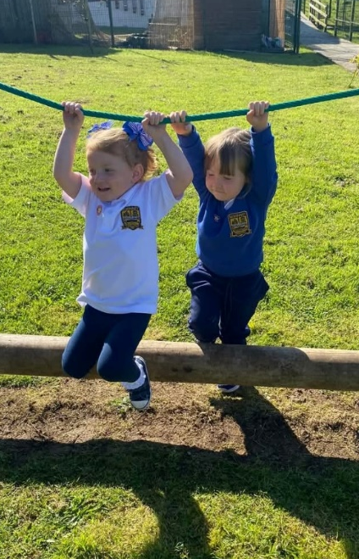
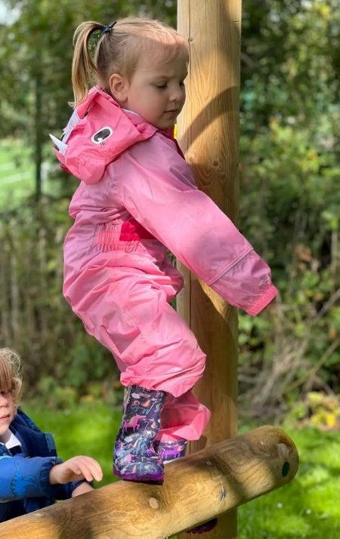

SCHOOL UNIFORM in Primary 1 - 4

School uniform consists of:
Black School Shoes suitable for both indoor and outdoor activities.



Girls
White Polo Shirt (with or without school logo)
School Sweatshirt (round neck)
Grey skirt / trousers.
White/grey socks or grey tights.
Winter Coat with hood.

Boys
White Polo Shirt (with or without school logo)
School Sweatshirt (round neck)
Grey trousers.
Grey / Black socks.
Winter Coat with hood.

School Uniform in P5 – 7
There are some differences in the P5 - 7 uniform to recognise their age and to prepare them for High School.
All pupils in P5 – 7 may be asked to wear a shirt / tie uniform at formal events / competitions.

Primary 5 – 7 school uniform consists of:
Black School Shoes suitable for both indoor and outdoor activities.

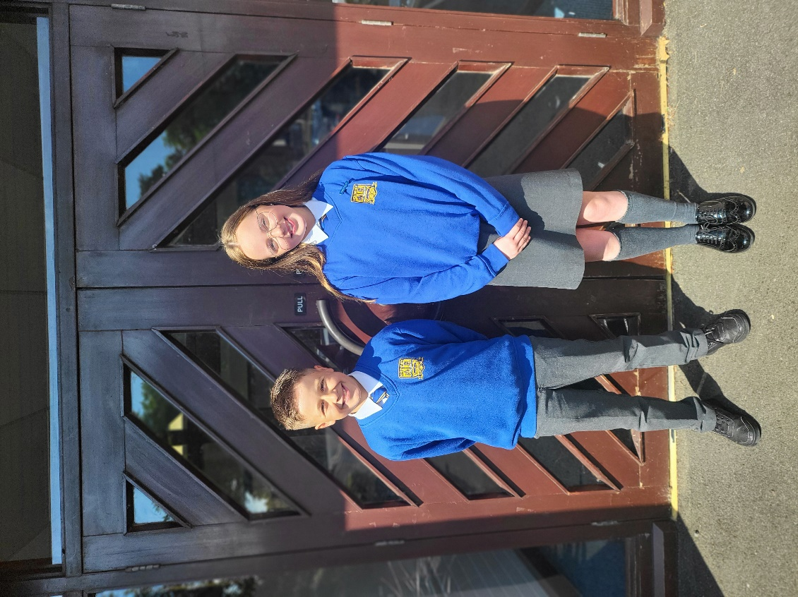

Girls
White Shirt and Tie
School Sweatshirt (v neck) or Cardigan
Grey skirt / trousers.
White/grey socks or grey tights.
Boys
White Shirt and Tie
School Sweatshirt (v neck)
Grey trousers.
Grey / Black socks.

Primary 7 pupils will be able to purchase their Leavers Hoodie in Term 2.

Optional Summer Uniform (during Term 3 only)

Girls
• Checked gingham dress or white polo shirt with plain black shorts / grey skirt.
• School Sweatshirt
• Trainers / School Shoes.

Boys
• White polo shirt with plain black shorts / grey short trousers.
• School sweatshirt
• Trainers / School Shoes.

• Other sports tops, hoodies etc. are not allowed to be worn over optional Summer uniform.

PE UNIFORM
Under Department of Education guidance, pupils should change for their PE lessons.

Since Covid, Primary schools have moved to children wearing a PE uniform on the day that there is PE. (two days per week – you will be informed of your child’s PE days in Sept)

Our school PE uniform for all pupils consists of:

• Blue T shirt with school badge. (plain blue or plain white also acceptable)

• Plain black shorts / plain black tracksuit bottoms / plain black leggings / black skort.

• Trainers (Trainers with Velcro fastenings are best for Years 1, 2 and 3)

• School tracksuit top.

• Girls may wish to wear black / navy school PE shorts under their skirt for active play.
Black skorts are also a good option.

• Other sports tops, hoodies etc. are not allowed to be worn over PE uniform.



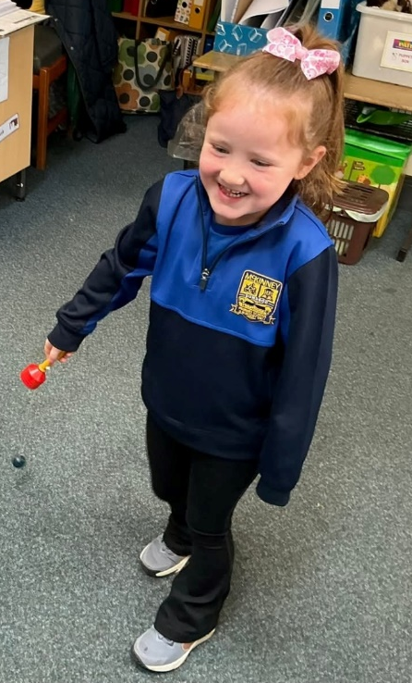
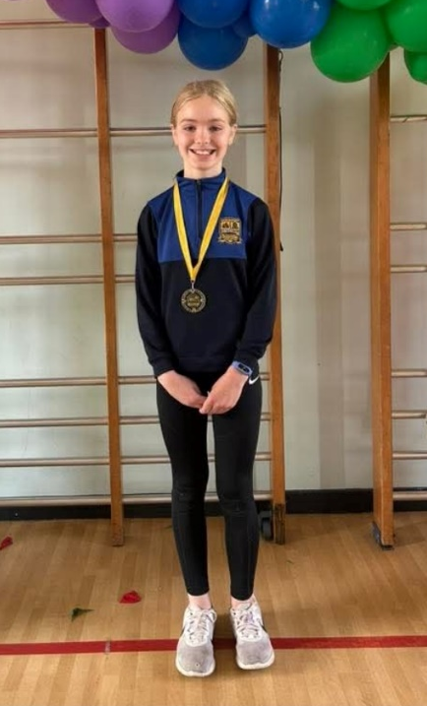

Stockists of School Uniform
Most items of our school uniform are available for purchase in high street shops and large
supermarkets.
The stockist for our crested school items, school PE kit and school tie is:
Thousand Stitches, Antrim.

Alternatively, McCall’s in Lisburn are stockists of our school branded jumpers.

Trips or Sporting Events
For class trips, sporting events and special occasions, staff will advise pupils on the most appropriate attire for the activity.

For formal events, staff may ask P5 – 7 pupils to wear their shirt / tie combination.

Children may also be asked to wear their own clothing, their own running gear, their own sportswear or school-branded running vests or jerseys (which school provides).

On specified non uniform days, pupils may wear their own style of clothes but we ask parents to avoid sending children in clothing which may cause offense.

Outdoor Learning
Your class teacher will outline in September what your child will need in order to participate in Outdoor Learning lessons.

Painting Uniform
Your class teacher will outline in September what your child will need to bring in order to participate in Painting / Craft lessons. This would typically be an oversized shirt / blouse from a parent which is no longer required.
Long Hair
Pupils are encouraged to tie long hair back at all times.
It is necessary for pupils to tie long hair back during P.E. activities (i.e. swimming and gymnastics) if the length of a child’s hair is deemed to be a concern due to health and safety considerations. ‘The Association for Physical Education’s Safe Practice in Physical Education and School Sport’, Seventh Edition (2008).

Jewellery
On health and safety grounds, we do not allow children to wear jewellery in our school.
The exceptions to this rule are plain gold or silver earring studs in pierced ears.
Jewellery is not permitted for swimming (P5, P6, P7) and earrings must be removed or covered with a swim cap.
Please note that watches are not considered items of jewellery and may be worn.
However, depending on the activity, it may be appropriate for children to be asked to remove their watches on health and safety grounds.

Uniform Grant
Financial assistance is available through the Education Authority’s ‘School Uniform Grant Scheme’ for
certain categories of pupils attending primary schools. Further details are available from
www.eani.org.uk/financial-help/free-school-meals-uniform-grants.

Non-Compliance with our School Uniform Policy
Where a pupil is not adhering to the school uniform policy, we will make discreet enquiries as to why this is the case as there may be a number of valid reasons for it.
Where financial circumstances are preventing pupils from wearing the correct uniform, we will be sensitive to the situation and allow parents sufficient time to purchase the required items.
Pupils should not feel uncomfortable or discriminated against because their parents are unable to provide them with the required items of uniform.
The school will assist with the offer of uniform from its Uniform Exchange where needed.

The Role of Governors
The Board of Governors supports the Principal and Senior Leadership Team in implementing the school’s Uniform Policy.
They consider all representations from parents regarding this Policy and liaise with the Principal to ensure that the Policy is implemented fairly and with sensitivity.

Monitoring and Review
The Board of Governors is rightly proud of how pupils look in their school uniform and express thanks to parents/guardians in anticipation of their valued support in this important area of school life.
Parent and pupil views are valued and considered when the Policy is being reviewed and will be taken into consideration at the next review of this policy.
The Governors and Principal will consider carefully any request for an exception to be made for any individual pupil, on the grounds of religion, race, gender or a medical condition.

